PROJECT AND TEAM INFORMATION

Project Title

PrepGenius – AI-Powered Quiz & Analytics Platform

Student / Team Information
Team Name: CodeVision | Avengers
Team member 1 (Team Lead)  First name - Anchal  University Roll Number – 2418257  Student Id – 240111430  Email – devendarsingh1008@gmail.com | 
Team member 2  First name – Mahi  Last Name - Jain  University Roll Number – 2418625  Student Id – 240121445  Email –mahijain041106@gmail.com | 
Team member 3  First name-Palak  Last Name-Rawat  University Roll Number-2419261  student ID-240121794  email-palakrawat268@gmail.com | 
Team member 4  First name -Yashvi  Last name -Bansal  University roll no. -2419154  student id -240121395  email id -yashvibansal736@gmail.com | 

PROPOSAL DESCRIPTION

Motivation

Students today are glued to old question papers. They want the inside scoop—what kind of questions turn up, which topics repeat, just how tough things get. But most end up bouncing from random PDFs to battered books, chasing links across a dozen websites. There’s no real order. Before long, they lose track of what they’ve done, skip practice sessions, and honestly, half the time, they have no idea if they’re actually improving. It all gets out of hand, and their exam prep takes the hit.
That’s what sparked this project. The idea’s simple: create a smart, interactive quiz platform for past exam questions, all built in Java. Not just another endless list of questions. This system actually helps you learn—timed quizzes, questions that ramp up in difficulty as you get better, detailed stats so you can watch your progress, even leaderboards to keep things interesting. Everything’s designed to push students toward regular practice and highlight exactly where they need to focus.
A key feature here is the chatbot-based study assistant. Lots of students hold back from asking questions or just don’t know where their weaknesses are. The chatbot acts like a mentor. It guides users through the system, breaks down results, calls out weak spots, offers hints, and gives advice for improvement. The whole thing feels personal and far more interactive.
Choosing Java isn’t just a technical flex. It’s about putting real software engineering concepts to work—object-oriented programming, modular design, database integration, user interface design, all of it. This project tries to close the gap between old-school exam prep and smart, modern learning tools. The goal: make studying less chaotic, more focused, and honestly, a lot more motivating.

State of the Art / Current solution

To solve the common problem students, face while preparing from previous year questions, this project introduces a Smart PYQ Quiz & Practice System developed using Java. Instead of studying from scattered PDFs and Websites,
Student gets Single, organized platform where they can practice questions, track their progress and understand their strength and weaknesses in a simple and effective way.
It allows students to create an account using their respective student ID’s and create their own password and log in their accounts after which they can attempt quizzes based on PYQ.
Questions are grouped by subject, topic and difficulty level, enabling focused and goal-oriented practice. Timed quizzes help simulate real examination conditions, improving students’ speed, accuracy, and time management skills.
After completing a quiz, users receive instant feedback along with correct answers, helping them learn from mistakes and strengthen their understanding. A major feature of the proposed system is performance tracking and analysis. The system stores quiz results and provides clear insights such as scores, accuracy, time taken, and topic-wise performance.
To keep users motivated and engaged, a leaderboard feature is included. By displaying rankings based on quiz performance, the system encourages healthy competition and regular practice among students.
An important and innovative part of this solution is the chatbot-based study assistant. Many students hesitate to ask questions or struggle to understand their performance. The chatbot acts as a friendly virtual mentor by guiding users through the system, analyzing quiz results, suggesting weak topics, providing hints, and recommending improvement strategies. This makes the learning process more interactive and personalized. From a technical perspective, the system is designed using Java and object-oriented programming principles, ensuring modularity, reusability, and easy maintenance. Overall, this proposed solution transforms traditional PYQ practice into a smart, engaging, and student-focused learning system, improving exam preparation while also helping the developer gain practical experience in real-world Java application development.

Project Goals and Milestones

The main objective of this project will include developing a complete PYQ Quiz & Practice System that will utilize Java to help students prepare for their exams through interactive learning and performance techniques.. The system will help students overcome the limitations of traditional static learning processes by providing intelligent testing, immediate feedback, and personalized learning assistance through analytics and a chatbot assistant.
One of the main objectives of this project is to develop a user-friendly quiz system that will help students practice previous year questions with facilities such as timed quizzes, random question selection, difficulty levels, and immediate scoring. Another major objective of this project is to develop a strong performance analysis system that will help track user performance, point out areas of weakness and strength, and assist students to improve their performance in a planned way. The inclusion of a rule-based chatbot will also make the system user-friendly by helping users to understand the system, analyze results, and provide suggestions for learning in real time.
From a technical standpoint, Students will be able to learn the basic Java programming concepts through technical training that will include object-oriented programming, modular programming, file handling, database connectivity, exception handling, and basic security concepts.
Project Milestones
- Requirement Analysis & System Design: Define project scope, features, and system architecture.
- User Management Module: Implement user registration, login, and role-based access.
- Question & Quiz Engine Development: Create question management and quiz execution logic with timers and scoring.
- Performance Analytics & Leaderboard: Develop result tracking, analytics, and ranking system.
- Chatbot Integration: Implement a string-matching chatbot to assist users and provide recommendations.
- Testing & Optimization: Perform functional testing, error handling, and performance improvements.
- Final Deployment & Documentation: Prepare final project report, presentation, and user guide.

Project Approach

- This system has a layered structure: there’s the Frontend, the Backend Engine, the Analytics Module, the Database Layer, and the Reporting Module.This way, it’s easy to keep everything straight. It’s also simpler to update or repair parts without messing up the whole system.
- The Frontend will run on JavaFX—or Swing, depending . This is where users log in, register, view their dashboard, take quizzes, view results, view analytics, and chat with the built-in bot. This project will have different set up role-based access too, so students and admins view different options and controls.
- Now, for the Java Backend Engine , this is where the action is. This is where logging in, taking quiz sessions, randomly selecting questions from the question bank, timer control, answer checking, and scoring occur. When a user takes a quiz, the engine assembles it on the fly, selecting questions based on subject and difficulty level.
- For questions, we have two sources. First, there’s a formal Question Bank in MySQL. Second, there’s a PDF Processing Module using Apache PDFBox. This part of the system extracts text from uploaded past year question PDFs, uses pattern matching to identify questions, and imports them into the database.
- The Chat Processing Module will follow a hybrid approach. For system commands such as “start quiz” or “show score,” it relies on rule-based matching. For requests such as explanations or hints, it accesses an API via HTTP, so users receive smarter and more helpful answers.
- The Scoring & Analytics Module consolidates quiz results, determines accuracy by subject, identifies areas of weakness, and provides feedback on performance. It also determines leaderboard positions based on cumulative scores.
- The Database that will be used in the project is MySQL/SupaBase. It will store all the details of the user such as roles , questions , quiz attempts , results , scores , chat conversations. We are using JDBC and the DAO pattern to ensure seamless interaction with the database.

System Architecture (High Level Diagram)

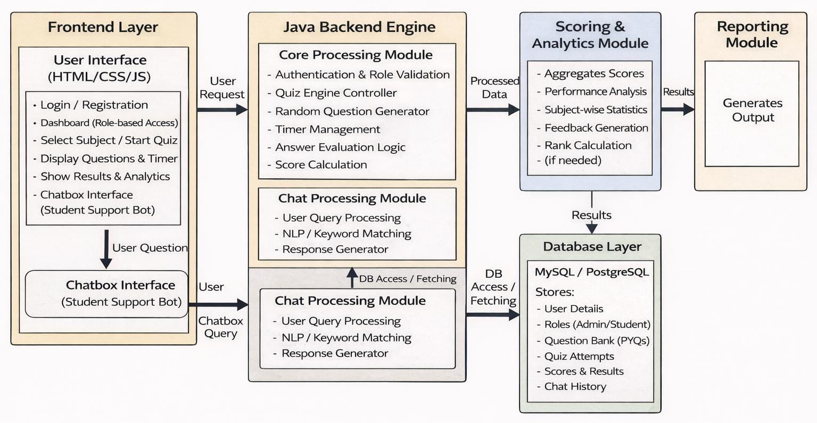

Project Outcome / Deliverables

The result of this project is the successful implementation of a Smart PYQ Quiz & Practice System using Java, which helps students in a systematic way to prepare for exams. The system assists students in shifting away from unorganized learning patterns by offering a single platform to practice previous year questions in a focused and systematic way.
With features like categorized and timed quizzes, students are better aware of exam patterns, key topics, and time management. Instant evaluation and feedback enable users to quickly grasp their errors and increase accuracy. The performance evaluation module helps students to track their performance, analyze their weaknesses, and manage their learning patterns more effectively. One of the major results of this project is the implementation of a chatbot-based study assistant, which helps students navigate through the system, evaluates quiz performance, points out weak topics, and offers useful hints.
From a technical point of view, this project enhances the practical knowledge of Java programming and object-oriented programming concepts like modular programming, database management, and user authentication.
Overall, the system improves exam preparation efficiency for students while providing valuable real-world software development experience for the developer.

Assumptions
There are certain assumptions we are considering before creating this project
- The user willl have an internet connection when you use the AI chatbot features.
- The PDFs you upload should be organized in a way that makes it possible to pull out questions.
- The database server is set up right and reachable while the app’s running.
- This project is sticking to the allowed API limits—just what's allowed for free or educational use.
- Students are here to get ready for their exams, not for anything else.
- And finally, this whole project is about academic learning, not for any kind of commercial launch.

References

- Oracle Corporation, Java Platform, Standard Edition Documentation. Available at: https://docs.oracle.com/javase/
- Schildt, H., Java: The Complete Reference, 11th Edition, McGraw Hill Education, 2018.
- GeeksforGeeks, “Java Programming and Quiz Application Development Tutorials.” Available at: https://www.geeksforgeeks.org/

